***Reverse a String Entered by the User***

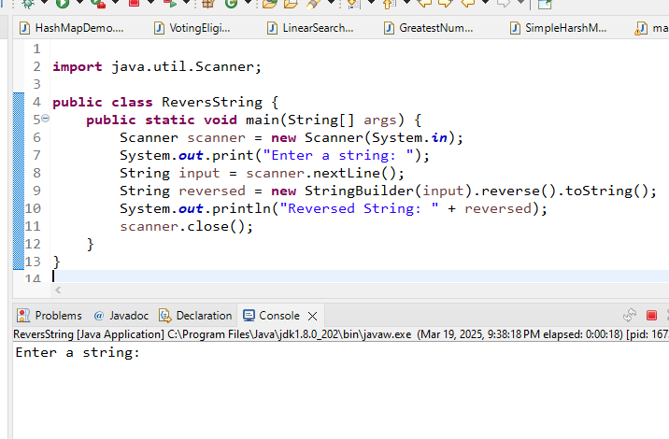

***Reverse Each Word in a String:***

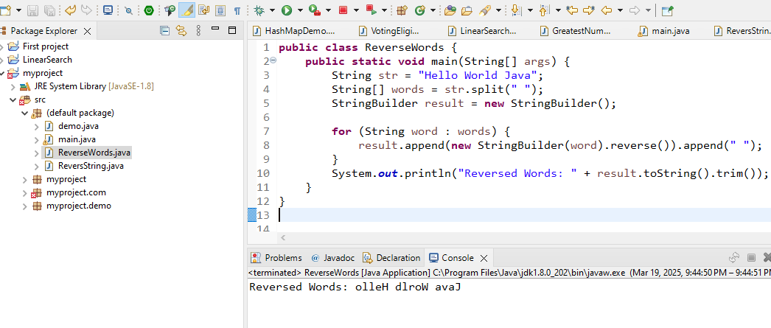

***3.Reverse a String Using a Loop and StringBuffer***

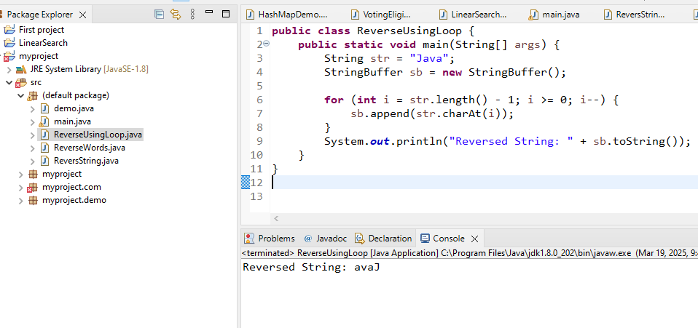

***4.Search for a Number in an Array***

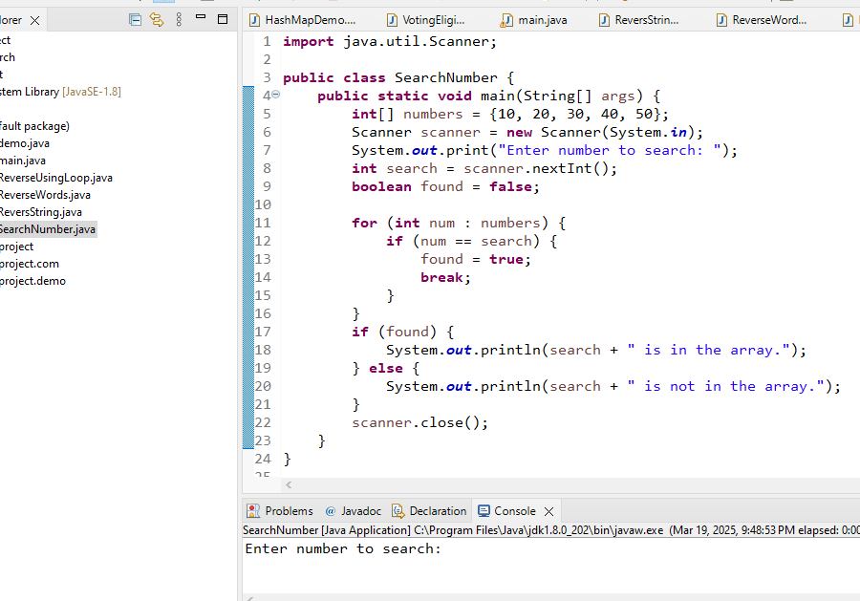

***5.Search for a Numeric Value in an Array***

